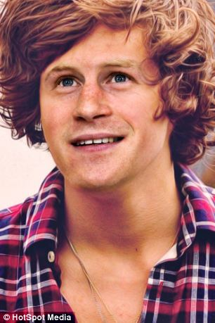 |  | 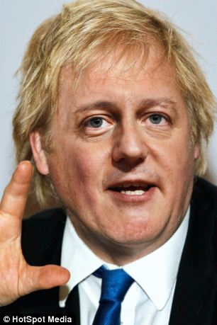
1) Prince Harry | 2) Harry Styles | 1)Boris Johnson | 2) David Cameron
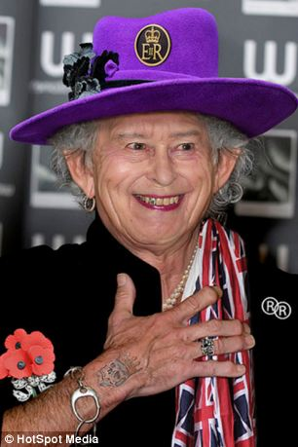 |  | 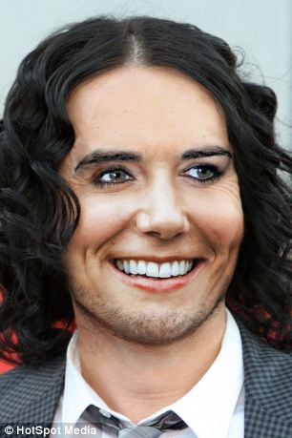
1) HRH Queen Elizabeth II | 2) Keith Richards | 1) Kate Middleton | 2) Russell Brand
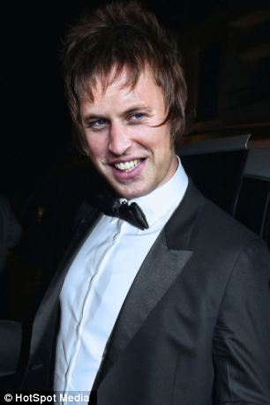 |  | 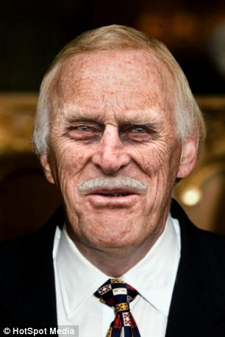
1) Prince William | 2) Liam Gallagher | 1) Prince Phillip | 2) Bruce Forsythe
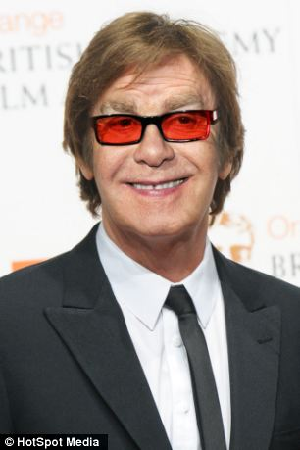 |  | 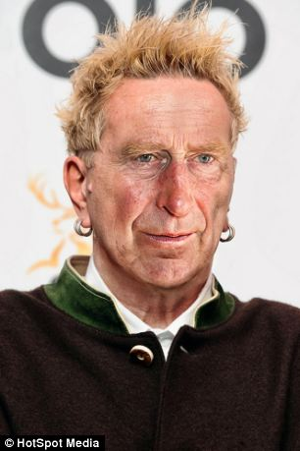
1) Elton John | 2) Paul McCartney | 1) Prince Charles | 2) Johnny Rotten
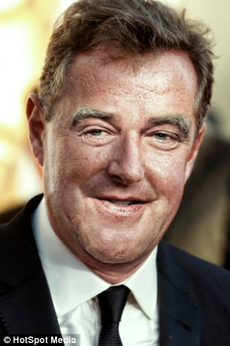 |  | 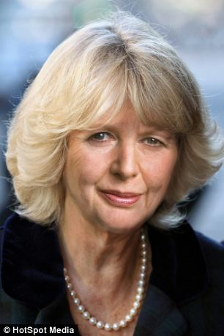
1) Piers Morgan | 2) Jeremy Clarkson | 1) Duchess of Cornwall | 2) Margaret Thatcher
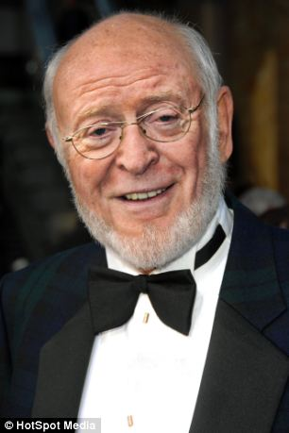
1) Michael Caine | 2) Sean Connery | 1) Teacher 1 | 2) Teacher 2
Which two well known faces have been morphed to make these images?

